Exploratory data analysis on bike sharing data:

* Scatter plot matrix
* 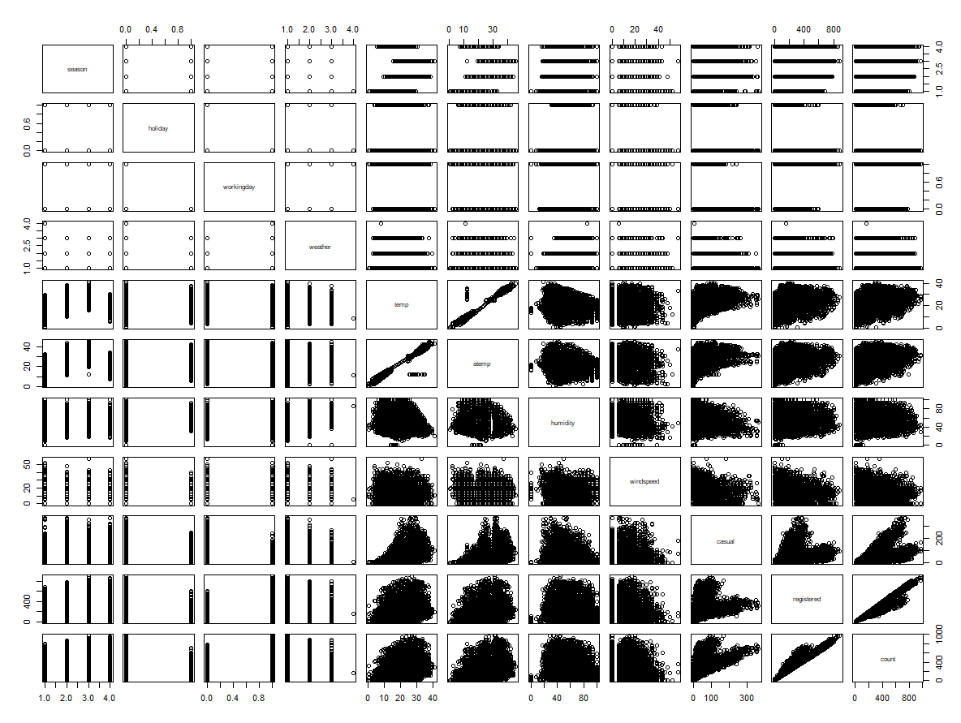
  + **Temp** and **atemp** seem to be very highly correlated – perhaps atemp is a function of temp in some way
  + **Registered** and **count** also seem to be very highly correlated with each other
* Registered vs. temp
  + 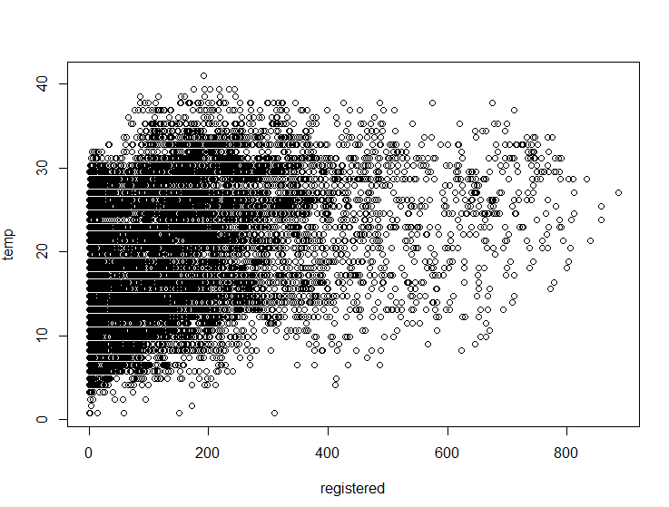
  + The higher the temp, the less registrations
* Registered vs. Humidity
  + 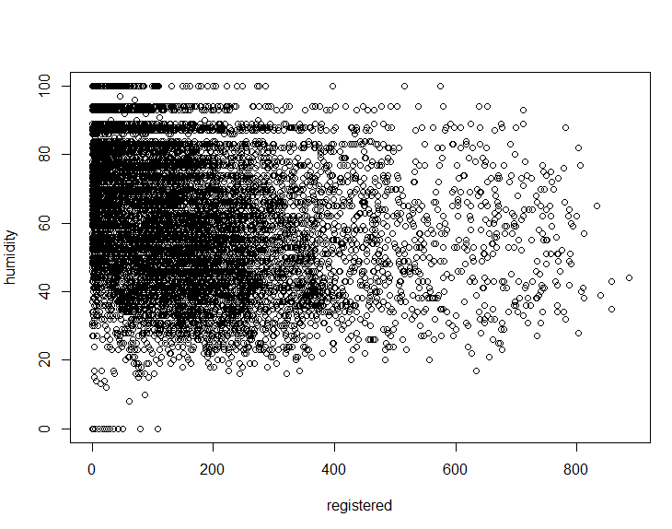
  + The higher the humidity the lower the registrations
* Registered vs. Windspeed
  + 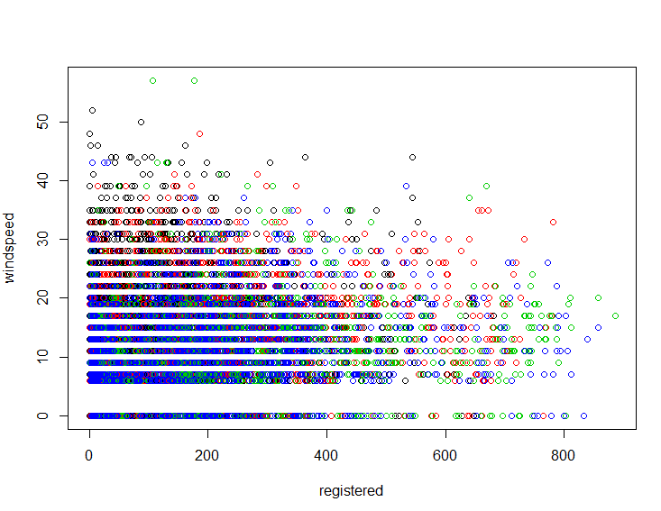
  + The higher the windspeed, the lower the registrations